**4.3.5 IT Infrastructure**

**Audio Visual facility – LT3 - Image 1**

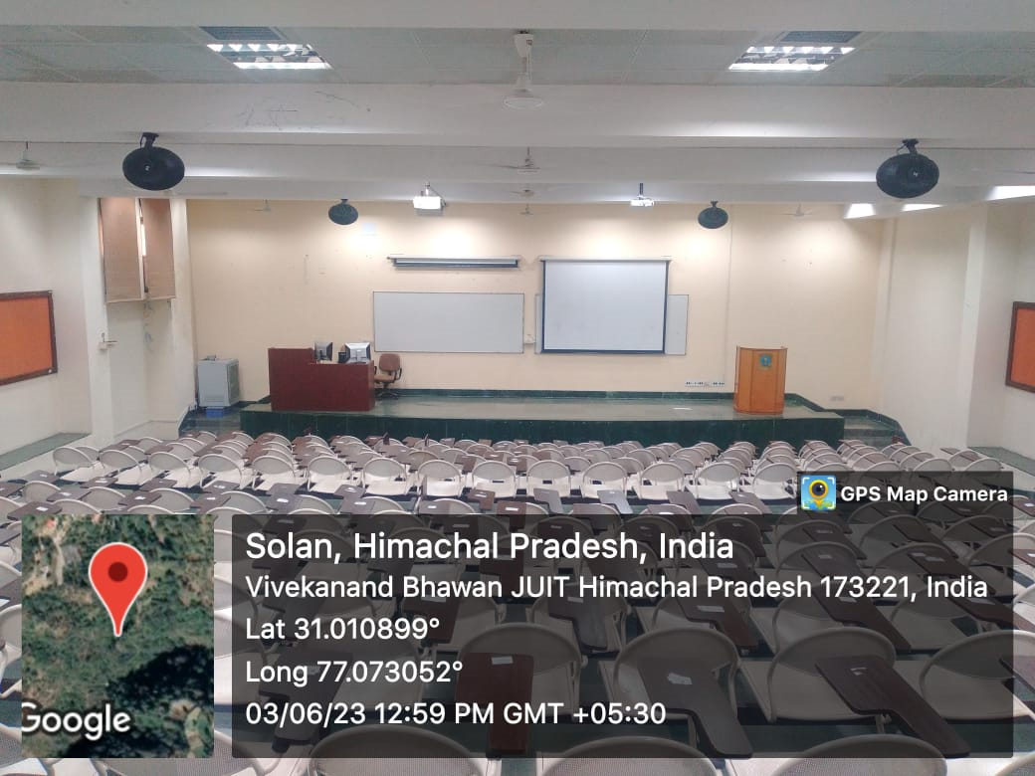

**Audio Visual facility – LT3 - Image 2**

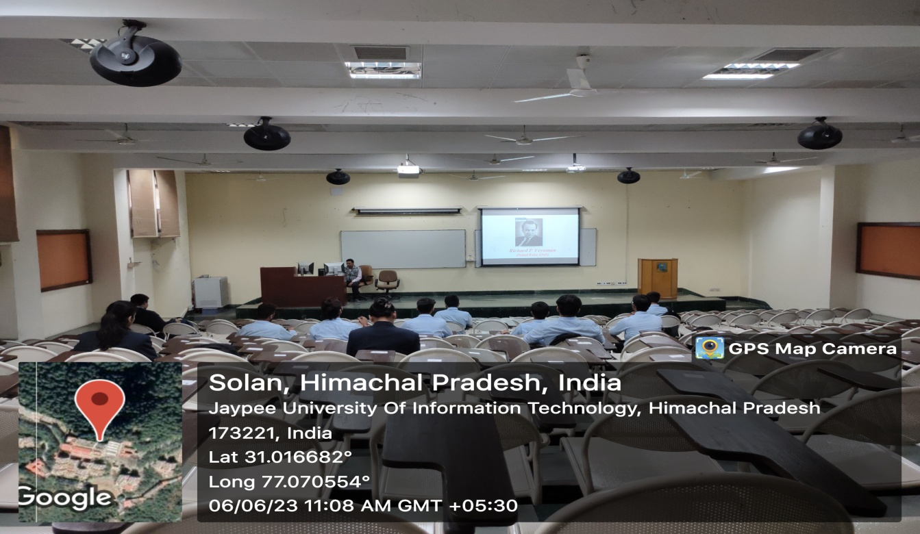

**Lecture Capturing facility – Image 1**

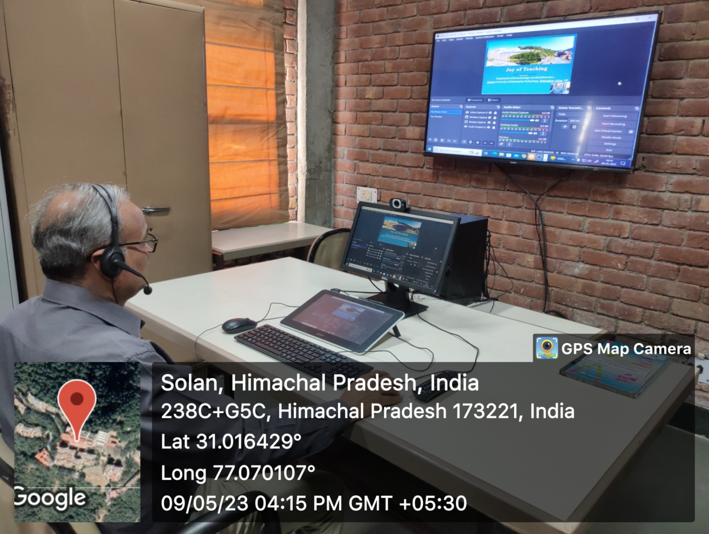

**Lecture Capturing facility – Image 2**

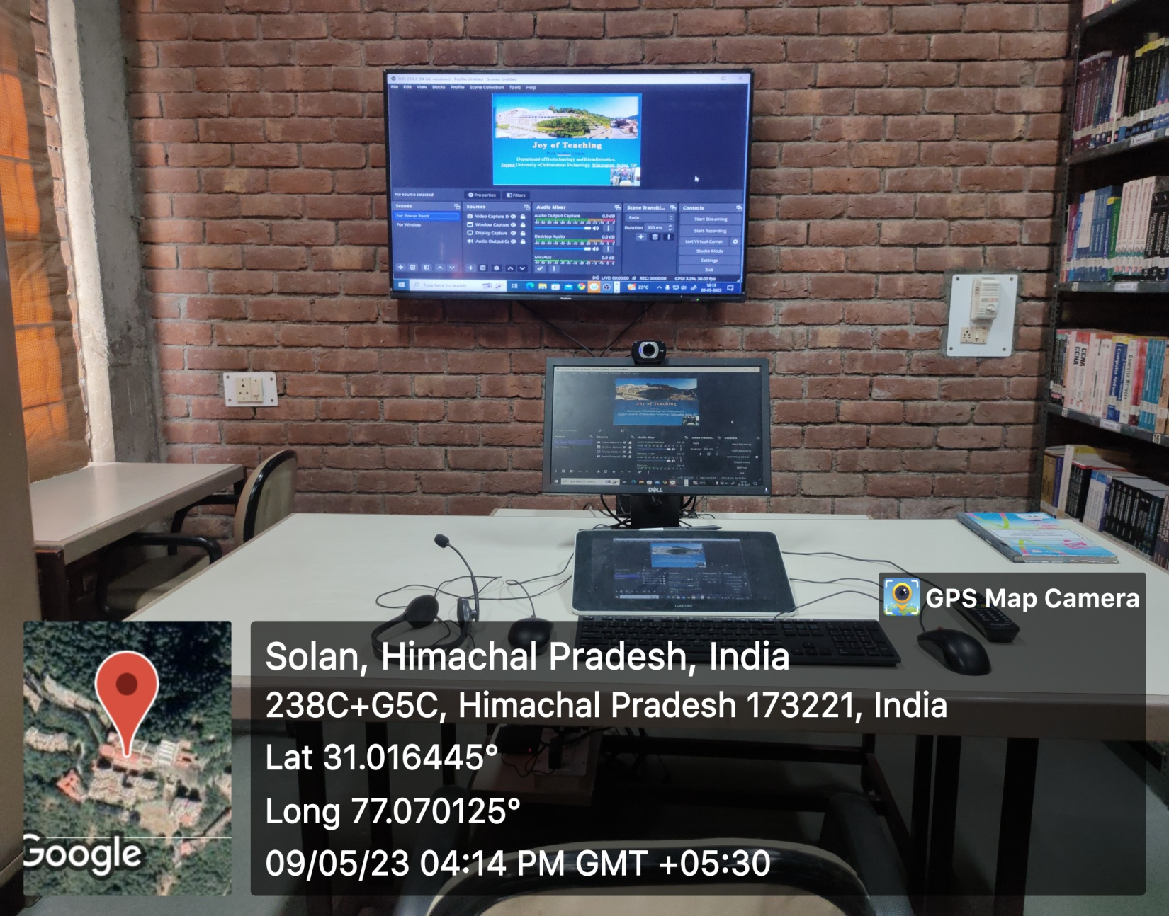

**Software (OBS –Open Source Software) for Editing**

